Curriculum Vitae Hanne Schillemans

PERSONALIA

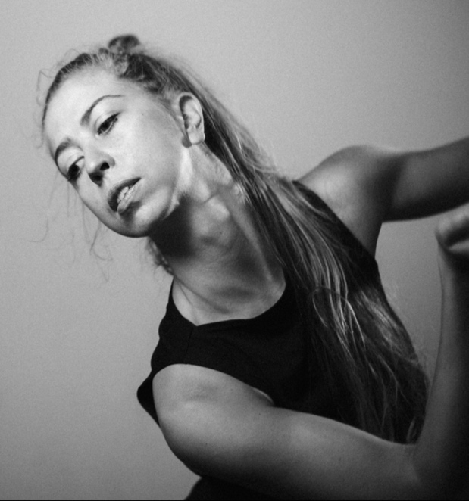
Name: Hanne
Surname: Schillemans Date/place of Birth: 26 December 1988
Ghent - Belgium
Nationality: Belgian
Gender: Female
Official address: Bommelstraat 34
9840 De Pinte
Belgium
Phonenumber: +32 485 45 59 78
E-mail: hanne.schillemans@hotmail.com
Websites www.hanneschillemans.com
www.spinecho.net
Weight: 58kg
Length: 176cm
Languages: Dutch (mother tongue), English, French
Driver’s license: B
Car: Yes

ABOUT HANNE

Born in Ghent, Hanne Schillemans is internationally active as a dancer, performer and choreographer since 2011.

During her dance-training at the Fontys Dance Academy Tilburg (NL), where she graduated in 2011, Hanne became captivated by the theatrical power of the body in motion.
She has worked together with United Cowboys, La Monnaie, Alla Sigalova, Dirk Brossé, Theater Tol, Teatro Comunale Di Bologna, Radical Hearts, Brussels Philharmonic, De Kwekerij Theaterproducties, LaMelis.

​Hanne is fascinated by cross-over settings, where dance is connected to other artforms such as theatre, music, architecture, photography and visual arts. She is always in search of possibilities to harmonize these forms of expression and to create new surprising totalconcepts.

Since 2016 she is putting her own artistic vision out there with [SPIN][ECHO], that she founded with composer Ralph Timmermans. Together with a variable group of dancers, musicians, actors, philosopher and scientists they are creating multidisciplinary performance art.

Currently they are working on a new project called ‘Blue Heroes’: Teaser Blue Heroes

Links:

Videoreel
Website Hanne
Column about Hanne by Docwerk TV
Website Spin Echo
Teaser Spin Echo
Short movie Spin Echo created for the Beautiful After Breast Cancer Foundation

DANCE EDUCATION

2007 – 2011 Fontys Dance Academy (HBO), Tilburg, NL
Bachelor degree in ‘Performing Theatre Dance’
Specialization: Contemporary dance and Dance-Theatre
Minor: Dance dramaturgy

Graduated in June 2011

2006 – 2007 Dance Academy Muda (MBO) , Ghent Belgium

1995 – 2006 Ballet, jazz and modern classes in amateur schools

GENERAL EDUCATION

2000 – 2006 High school in Ghent (VWO), K.A. Voskenslaan
Department ‘Sciences-Sports’
Graduated in 2006

1996 – 2015 Music, piano, and singing classes private and in group

PROJECTS AS A FREELANCE DANCER/PERORMER/CHOREOGRAPHER

2019
- Creationproces ‘Blue Heroes’, by Spin Echo
2018
- ‘In case’, by United Cowboys
- ‘Hotel Watercage’, by Theater Tol
- ‘We Want More’ by United Cowboys
- ‘Niet helemaal’, a children’s performance by Gratis Walhalla
2017
- ‘Match’ by United Cowboys
- ‘Just before artificial intelligence’, by Spin Echo
- ‘Voices of Hope' by Hanne Schillemans and Dirk Brossé
- ‘Encounters at risk’ by Radical Hearts/Pé Vermeersch
- ‘`The Now Machine’ by Spin Echo
2016
- ‘Mudachiefs’ by Jack Gallagher
- ‘Echoes of silent voices’ by Hanne Schillemans and Dirk Brossé
- ‘Plastic’ by United Cowboys
- ‘Landlopers 4 ‘Het Rumoer van de stad ontvlucht’, by De Kwekerij
- ‘Show (er)’ by Spin Echo
- ‘De Fluisterende Stad 3 - Het Familierecept’ by De Kwekerij
- ‘Inside-out’ by Dirk Brossé
- Founder of Spin Echo, a performance collective.
2015
- ‘Le black stivali et la chaise rouge’ by Lamelis
- ‘Stand Alone’ by United Cowboys
- ‘Dwaallumen’ by Beeldjutters
- ‘ Black White and in Between’, by Hanne Schillemans, in coöperation with Dirk Brossé and the Brussels Philharmonic.
- ‘On false tears and outsourcing’, by Cally Spooner
- ‘Jenufa’, Teatro Comunale de Bologna. Choreography: Alla Sigalova, Regie: Alvis Hermanis
- ‘Four Elements’, by Hanne Martine Geerinckx,
- ‘African Loop’, by Hanne Schillemans, in coöperation with Dirk Brossé.
- ‘Opaco Negro Blanc’, by LaMelis
2014
- ‘De Fluisterende stad 2’, by De Kwekerij
- ‘Figures that wonder’ by United Cowboys
- ‘Elena’, solo by Compagnie Monica
- ‘Time-lapse’ by Hanne Schillemans, with percussionist Johan Reijnders
- ‘Daphne’ Opera La Monnai Brussels, Choreogaphy: Aline David, Regie: Guy Joosten
- ‘Believe’ by Min Hee Bervoets and Michel Froget for the openingsceremony of the Special Olympic Games
- ‘BURN’ by United Cowboys - a 4 hour improvisation based production. (still touring sporadically)
- ‘Speakers’, by Anne Parleviet
2013
- ‘Jenufa’, Opera La Monnai Brussels. Choreography: Alla Sigalova, Regie: Alvis Hermanis,
- ‘TRIPPP’, by Lucie Petrusova
- ‘Multiversum the Challenge’, by Teater Exces,
- ‘VTM terrazza’ by Compagnie MiLa/VTM
- ‘Straatjes kleuren’, by Teater Exces
- ‘Beginings’, by Hanne Schillemans
- ‘Moeders’ by Hanne Schillemans
- ‘Project X’, by company MiLa
2012
- ‘Two Times Soft’ Solo by company United Cowboys (still touring sporadically)
- ‘WHO-Final’ by United Cowboys
- ‘Corazôn de angeles’ by Theater Tol (still touring sporadically)
- ‘Pedaleando hacia el cielo’ by Theater Tol (still touring sporadically)
- ‘Madammen’ by Hanne Schillemans
- ‘Roots’ by Hanne Schillemans
- ‘Lust for Life’, by United Cowboys
2011
- ‘Vuurvleugels’, by stichting Phaedra
- ‘ 9 Nieuwe Naakten’ by company United-C
- ‘Roots’, by Hanne Schillemans
- ‘Twist and Shout’ by Uri Ivgi and Johan Greben @ Fontys
- ‘Jimmy Smith and the Heartbreakers’ by Milla Virtanen @ Fontys
- ‘Loops’, by Uri Ivgi @ Fontys
2010
- ‘WHO TOO’, by United Cowboys
- ‘WHO Cycle, by company United Cowboys
- ‘Amore in three’, by Sara Wictorowics @ Fontys
- ‘Die Schöpfung’, by Marc van Loon and Jean-louis Barning @ Fontys
- ‘Sporen ‘ by Leine & Roebana @ Fontys
2009
- ‘Dead Beat’, by Yvonne Weschke (Club Guy and Roni) @ Fontys
- ‘Maggots and Butterfly’s, by Raymond Esterhuizen @ Fontys
- ‘Speechless, by Johan Greben @ Fontys
- ‘Zeropoint’, by Gizem Bilgen @ Fontys

TEACHING

- 2012 – now: Giving workshops Contemporary dance, Improvisation and Composition

